KOREA ATOMIC ENERGY RESEARCH INSTITUTE
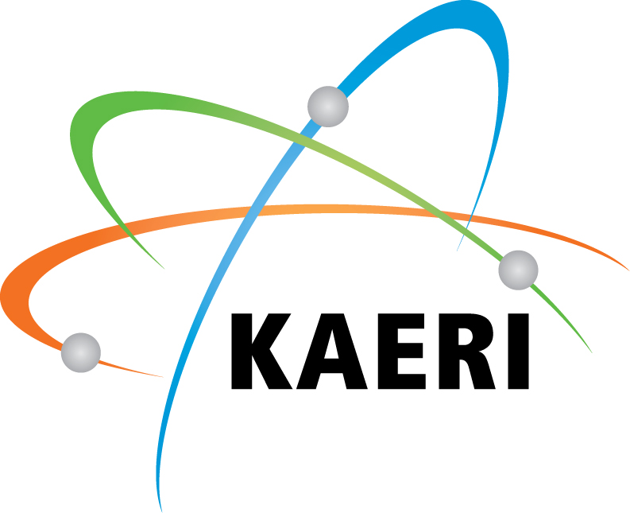
111, Daedeok-daero 989beon-gil, Yuseong-gu, Daejeon Republic of Korea
Tel: +82-42-868-2677 Fax: +82-42-868-8077 E-mail: ygkwon@kaeri.re.kr

Lecture Application Form

Training Institution | Korea Atomic Energy Research Institute
Training Institution | 111, Daedeok-daero 989beon-gil, Yuseong-gu, Daejeon, Korea
Applicant | Organization
Applicant | address
Application Course | key Issues in the World Nuclear Industry Today
Application Course | Training Period | 21 ~ 23 May, 2014
Application Course | Training Fee | 500,000 KRW or USD 500
Name in Full
Passport Number.
Valid until
Phone No.
E-mail Address

Please fill out the form and email (ygkwon@kaeri.re.kr) or fax as early as possible
FAX : +82-42-868-8077

